**UNIVERSIDAD DE PUERTO RICO**

**RECINTO UNIVERSITARIO DE MAYAGÜEZ**

**FACULTAD DE INGENIERÍA**

**DEPARTAMENTO DE INGENIERÍA ELÉCTRICA**

**Proyecto Final**

**Architecture and Design**

**Juan E. Hernandez Miranda**

**Fernando A. Maldonado Melendez**

**Vicari M. Pastrana De Jesús**

**INEL 4206 Sección: 020**

**24 de marzo de 2023**

Logical View



The trolley tracker consists of communications between a user's display (phone) and the trolley’s location. The Trolley Class consists of location and status. Its responsibility is to decode the transmission signal of a landmark. The Location References class consists of a library of different landmarks that transmit different signals from the Signal System and Time estimating code. Its responsibility is to transmit to the Digital Assistant (Siri/Ok Google) the location of the Trolley and how long it will take to get to the user. The Display will use the information given to the Digital assistant to inform the user of the Trolley’s location and how long it will take to arrive at the user’s location.

Processor View

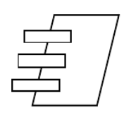



























In the case shown in Figure 2, it would be composed of a "Terminal Process", in this case, a cell phone that depends on a message such as "input", in our case this message could be "Hey Siri, Where is my trolley ”. At the same time, this cell phone communicates with our "Main Controller" which would be our server in AWS. This server is in charge of interpreting the information provided by the ESP32 to send it to the cell phone that will be in charge of communicating the requested information. On the other hand, the ESP32 that would perform the function of our "Controller Task High Rate" would detect any variation of the data collected by our "Controller Task Low Rate" composed of the code assigned to interpret the information that the “Hardware” collects through different physical devices. Both parts of the “Controller Task Low Rate” (Software and Hardware) are kept in a constant loop, collecting and interpreting information so that the “Controller Task High Rate” can detect a significant variation in the data.

Development View

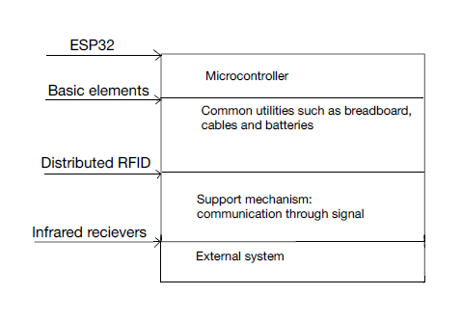

Here we’re naming some of the materials that are going to be used to achieve this

project. Throughout the work there may be some changes and maybe we have to add

materials so we can complete it but this is what it will allow us to start the project.

Physical View

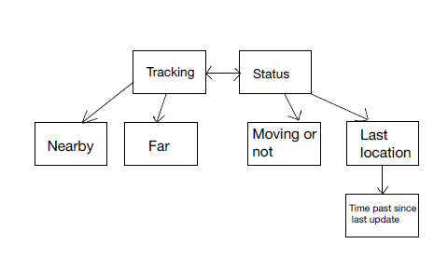

.

The ESP32 is going to have the main function of tracking the location or giving me the status of the trolley through the cell phone. When it’s tracking the trolley it’s going to tell me through a signal if it’s nearby or far and when the ESP32 processes that signal it will send the message to the cellphone. The same thing is going to happen when it gives me the status, it’s going to check if is moving or not or the last location and how much

time it has passed since the last location.

Scenarios





From this diagram one can observe that the process starts with the user asking the digital assistant (Siri in this case) “Hey Siri, where is my trolley?”. When the question is made, the assistant stores the user’s location and asks the ESP32 (Trolley) to read the signal transmission of the nearest building. The Location references (LR) looks into a list of buildings with their respective signal ID, in this case, the signal transmitted was from the chardon building. Then the user location is taken into account and the LR looks into a list with the estimated time difference between buildings. The Location and status is transmitted to the ESP32 which then tells the digital assistant and finally the digital assistant tells the user where the trolley is and how long it will take to arrive at user location